**SHADOW PRIEST**

**DESIGN DOCUMENT**

By Struthio_Games for the 2024 Pirate Software Game Jam

**Introduction 2**

Game Summary 2

Inspiration 2

Player Experience 3

Platform 3

Development Software 3

Genre 4

Target Audience 4

**Concept 4**

Gameplay overview 4

Theme Interpretation (Sacrifice Is Strength) 4

Primary Mechanics 4

Secondary Mechanics 6

**Art 6**

Theme Interpretation 6

Design 7

**Audio 7**

Music 7

Sound Effects 7

**Game Experience 7**

UI 7

Controls 7

**Development Timeline 8**

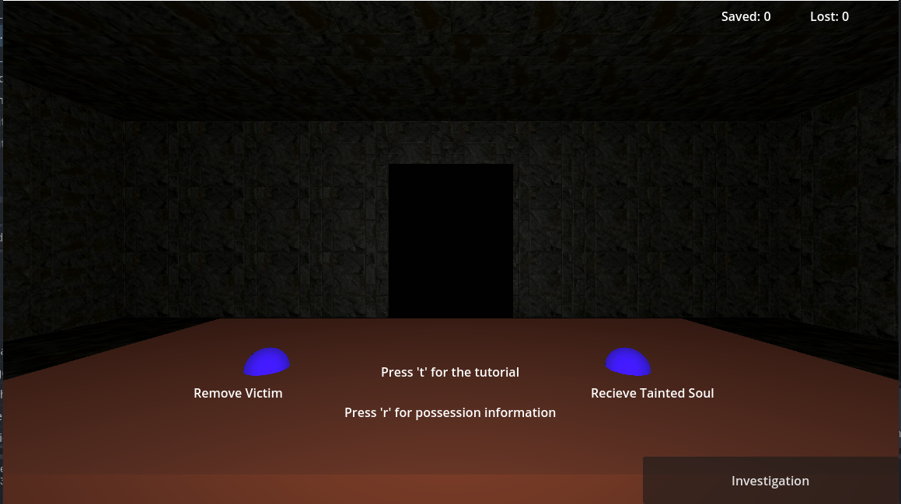

NOTE: This is my first ever game, let alone with Godot. I am a a self-trained software developer, so I went at this project in a “code first” mentality. Some of it may have benefited from that aspect, but for one person I believe what I have made is “good”. I am nervous to submit this having seen how good the other projects are, but I thank whoever you are for playing this game and reading my rambling. Please enjoy!

**Introduction**

**Game Summary Pitch**

Shadow Priest is a puzzle-based game about solving the “possession” that is hinted about in the victim’s shadow- the remedies of which are holy item shadows mixed together.

**Inspiration**

**Potion Craft**   
  
Potion craft is the original inspiration for this game- I used the customer system initially after its own system, where a problem is brought to the alchemist to solve, and specific ingredients are used to make the potion. The current way the alchemy works started as a very simplified version of Potion Craft’s alchemy system.

**Phasmophobia**  
  
Phasmophobia’s influence comes in, in the way the various possessions are handled. Each of them has specific characteristics the player must account for and then remedy using the holy items. I also use the dark lighting and atmosphere to highlight the spooky portion of the shadows and cursed nature of the victims.

**Player Experience**

The player navigates between 3 screens- “Greeting”, “Investigation”, and “Alchemy” screens where the player spawns the “victim” being possessed and goes through the investigation process to determine the root possession. The “Alchemy” screen is there to then have the player manipulate shadows so that they can create the remedy for the specific victim. There is then a counter for successes and failures (“save” and “lost”), that tracks how many times the player either lost a customer or saved them.

**Platform**

The game is developed to be played online in a web browser or on PC

**Development Software**

* Godot 4.2.2 for programming
* Blender for graphics
* Audacity music and SFX

**Genre**

Singleplayer, puzzle, casual, horror

**Target Audience**

This game is for those that want a little spookier of a game, light horror elements with lighting and sound- but that also want a bit of a puzzle solver.

**Concept**

**Gameplay overview**

The player is a “priest” that goes through a greeting and investigation phase to figure out the type of haunting/possession a victim has. The player then has to determine the proper remedy for the possession before they lose their charge (health to 0). The game tracks success and failures in a counter.

**Theme Interpretation (Shadows and Alchemy)**

**‘SHADOWS’– The game is inherently built around shadows of physical things: the player has to investigate manipulated shadows, use shadows for potions, and light (destroying shadows) actively hurts the victim**

**‘ALCHEMY’ – To create the solution to fix the possession, the player has to create a potion using alchemy and shadows according to a recipe in the game.**

Shadows play a massive and central role in this game as everythign from investigation to solution building relies on them. The alchemy comes in to actually create the solution that is required for the victim using those shadows.

**Primary Mechanics**

| **Mechanic** | **Picture From Game** |
| --- | --- |
| **Spawning** a  Allows the player to randomize their encounter a little more than just “one-and-done” spawns |  |
| **Flashlight** a  The directional light is how shadows are manipulated in the game; it is rotated towards the center so the player can move it around freely. |  |
| **Holy Object** a  The player needs to use these to create the remedies that will fix the haunting. |  |
| **Cauldron** a  A red targeting location is made for the player to actually add the shadow to the cauldron, this cauldron stores and displays the ingredients added so far. |  |

**Secondary Mechanics**

| **Mechanic** | **Picture From Game** |
| --- | --- |
| **Emptying Items List** a  If the player makes a mistake, they need a way to empty the cauldron without just giving the potion to the victim. |  |
| **Score Tracking** a  A counter was added to keep track of a player’s performance: “Saved” and “Lost” which will show how well they are doing at solving the game. |  |

**Art**

**Theme Interpretation**

With my use of holy symbols and possessions I chose to make the art a more medieval setting with stone walls and simplistic stone features in the surrounding. This makes the ambiance a little scarier as well as the darkness the player can’t see behind the walls they are using as a background show in front of them.

**Design**

There is very little color in the game which means the player is somewhat “stuck” in the dark with walls nearby- adding to the claustrophobia. The darker colors stick with the shadow theme not allowing the player to get away from the darkness.

**Audio**

**Music**

Adding to the rest of the horror setting- there is a constant noise of a storm in the background softly. It is to fill the player’s senses with noise to discourage any immersion breaking, while still being on theme with the horror sounds.

**Sound Effects**

To add some feedback for the player I’ve added noises to certain actions- ringing up a new customer, saving or losing a victim, and adding something to the cauldron for example. These are here just for the player to know that their actions actually did something.

**Game Experience**

**UI**

A simple UI is overlaid on the game to allow for scene switching and score display, as well as buttons for certain events- feeding the potion to the victim or clearing the cauldron for example- in the scenes they are relevant to.

**Controls**

**Mouse:**

Controlling all elements in the game

**Development Timeline**

**MINIMUM VIABLE PRODUCT**

| **#** | **Assignment** | **Type** | **Status** | **Finish By** | **Notes** |
| --- | --- | --- | --- | --- | --- |
| 1 | Learn Godot Tutorial | Tutorial | Finished | 7/18/2024 | Using BornCG’s Godot 4 tutorial |
| 2 | Create basic assets | Assets | Finished | 7/20/2024 |  |
| 3 | Create shadow elements in the game | Assets | Finished | 7/21/2024 |  |
| 4 | Create basics of scenes | Scenes | Finished | 7/23/2024 |  |
| 5 | Program shadow changes and spawning | Code | Finished | 7/26/2024 |  |
| 6 | Scene changing overlay | Code | Finished | 7/26/2024 |  |
| 7 | Add victim variables and tracking | Code | Finished | 7/27/2024 |  |
| 8 | Add overlay menus for possessions | Code | Finished | 7/27/2024 |  |
| 9 | Add save and fail variables | Code | Finished | 7/30/2024 |  |
| 10 | Fix overlay explanation and recipe menus | Code | Finished | 7/30/2024 |  |
| 11 | Add GridMap using blocks from Blender | Scene | Finished | 7/30/2024 | Reference for material used (1k): [Tiles 086 on ambientCG](https://ambientcg.com/view?id=Tiles086) |
| 17 | Add SFX | SFX | Finished | 7/30/2024 | References:  [Ding | Royalty-free Music - Pixabay](https://pixabay.com/sound-effects/ding-101377/)  [Howling winter storm ambient sounds | Royalty-free Music - Pixabay](https://pixabay.com/sound-effects/howling-winter-storm-ambient-sounds-6756/)  [Laugh demon sound effect 23 | Royalty-free Music - Pixabay](https://pixabay.com/sound-effects/laugh-demon-sound-effect-23-11505/)  [Short Choir | Royalty-free Music - Pixabay](https://pixabay.com/sound-effects/short-choir-6116/)  [Luggage Drop 1 | Royalty-free Music - Pixabay](https://pixabay.com/sound-effects/luggage-drop-1-47660/)  [Spacebar Click (Keyboard | Royalty-free Music - Pixabay](https://pixabay.com/sound-effects/spacebar-click-keyboard-199448/) |
| 18 | SUBMIT | Final | Finished | 7/30/2024 | Create Itch Page and upload |

**BEYOND (if ahead of schedule / extra time)**

|  |  |  |  |
| --- | --- | --- | --- |
| Difficulty “multiplier” | Asset | Not started | A bottle of booze that would make the light damage amplified and shake the camera. Stacks with number of drinks |
| Extra demons | Code | Not started |  |
| Start/pause Menu | Scene | Not Started |  |